Hiring Process Analytics

Project Description

Finding the right person during the hiring process is key to a company's success. It's crucial for HR to consider various aspects when selecting a candidate, as it impacts the growth and development of both the company and the individual. Therefore, hiring decisions should be made thoughtfully.

APPROACH

1. Download the dataset

2. Approach the solution by performing MS Excel formulas.

3. Analyze the solutions.

4. Note them down.

Tech Used

MS-Excel to perform the

statistical analysis on the data provided

Ms-Excel used to perform the statical analysis

Tasks

**A. Hiring Analysis: The hiring process involves bringing new individuals into the organization for various roles.**

**Task: Determine the gender distribution of hires. How many males and females have been hired by the company?**

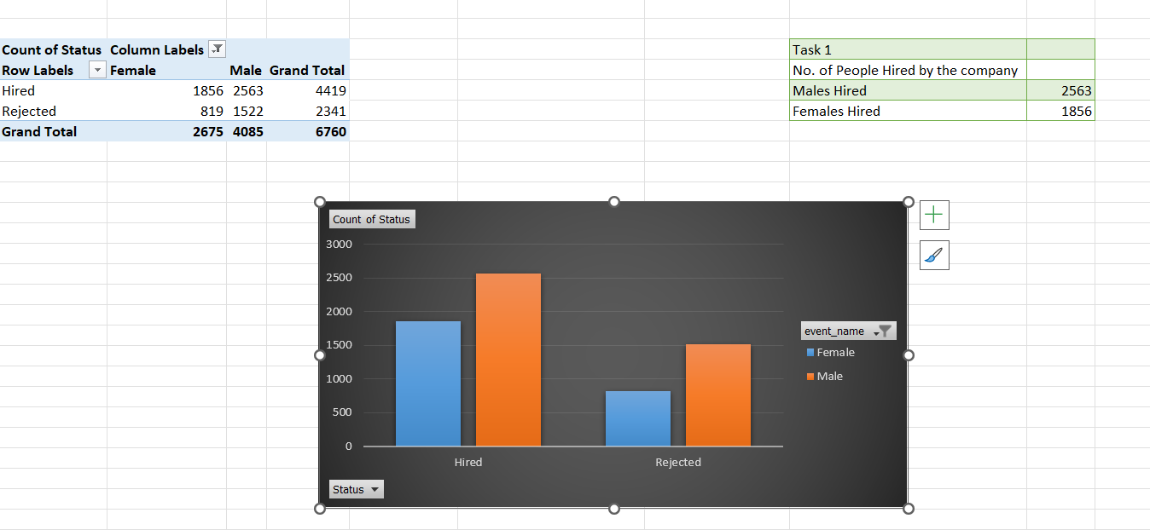

**B. Salary Analysis: The average salary is calculated by adding up the salaries of a group of employees and then dividing the total by the number of employees.**

**Task: What is the average salary offered by this company? Use Excel functions to calculate this.**

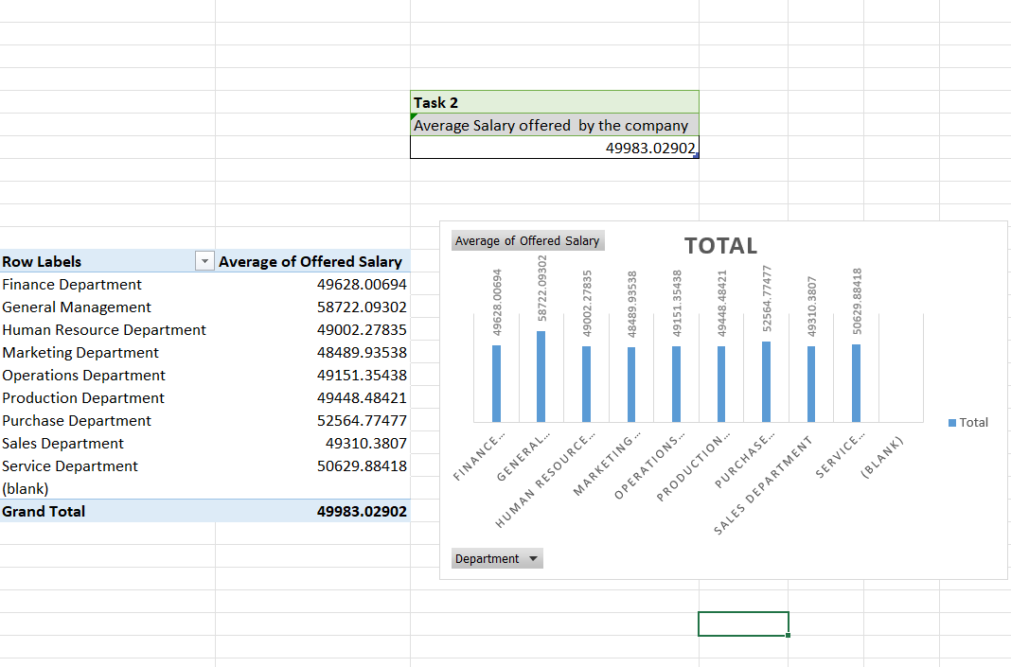

**C. Salary Distribution: Class intervals represent ranges of values, in this case, salary ranges. The class interval is the difference between the upper and lower limits of a class.**

**Task: Create class intervals for the salaries in the company. This will help you understand the salary distribution.**

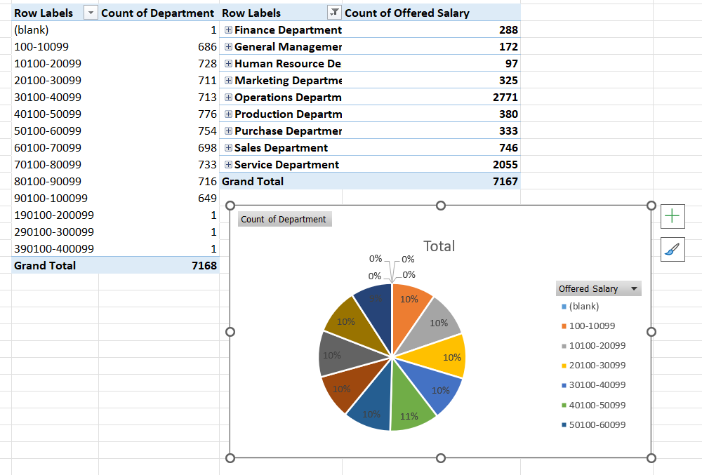

**Departmental Analysis: Visualizing data through charts and plots is a crucial part of data analysis.**

**Task: Use a pie chart, bar graph, or any other suitable visualization to show the proportion of people working in different departments.**

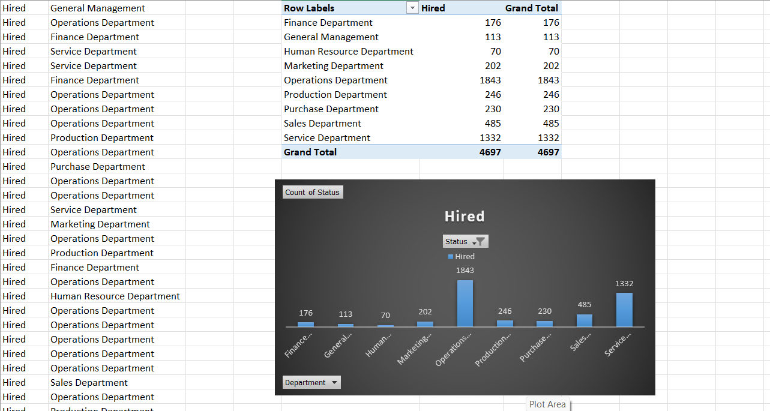

**E. Position Tier Analysis: Different positions within a company often have different tiers or levels.**

**Task: Use a chart or graph to represent the different position tiers within the company. This will help you understand the distribution of positions across different tiers.**

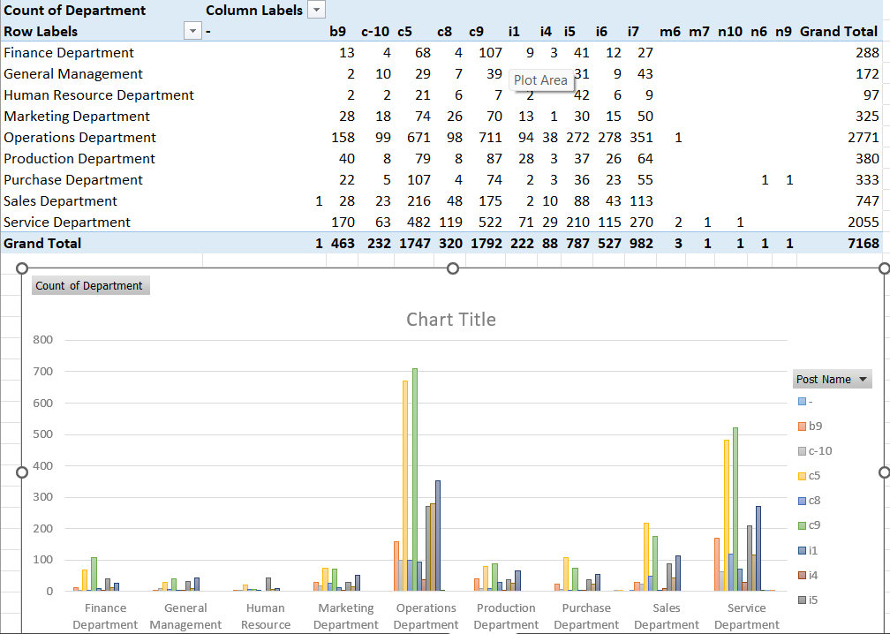

**Result**

**From the above analysis we find that Total 4419 people were hired in the total no. of Female were 1856 and Males were 2563.Average salary in the company offered was 49983. From the class interval of 10000 we found that the highest salary offered slab was between 40100-50099. And the total hired people were in operations department total of 1843 people and 1792 people were opted for the post of c9**

**Drive link**

[**https://drive.google.com/drive/folders/1NVesxc6219-ckqmWNukoNqkHj_4rOP-L?usp=sharing**](https://drive.google.com/drive/folders/1NVesxc6219-ckqmWNukoNqkHj_4rOP-L?usp=sharing)

**Excel File**

[**https://docs.google.com/spreadsheets/d/1EZ2v600EksmM8SA9W-XhMcLpFR2yPFbh/edit?usp=drive_link&ouid=113697873758793300085&rtpof=true&sd=true**](https://docs.google.com/spreadsheets/d/1EZ2v600EksmM8SA9W-XhMcLpFR2yPFbh/edit?usp=drive_link&ouid=113697873758793300085&rtpof=true&sd=true)